Michael P. Miller
1408 Orchard Street Email: 26062michael@gmail.com
Fairmont, WV 26554 Phone: (304) 914-1676
Objective To be able to work in an Entry-Level Position in the areas of Electronic Engineering and Computer Science to contribute my expertise and knowledge in electrical processes and applications such as designing, testing, and troubleshooting.
Education 2018-present: Fairmont State University, Fairmont, WV
B.S. Electronics Technology, all requirements completed (Expected Spring 2023)
Computer Science and Mathematics Minors (Expected Spring 2023)
GPA: 3.73

Weir High School, Weirton, WV 26062
Valedictorian Class of 2018
GPA: 4.125

Related Experience Electronics Lab Assistant (Fall Semester of 2021)
- Worked with students in the electronics field within a lab setting.
- Facilitated labs and assisted students when troubleshooting was needed.
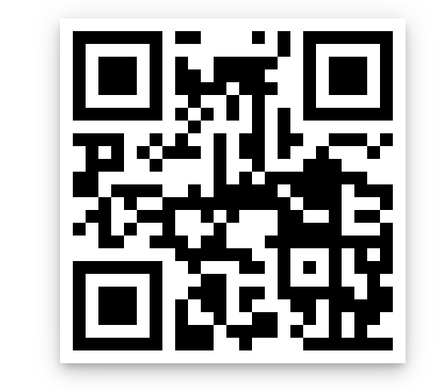 Electronics Senior Project (Spring Semester of 2022) Scan QR code to view presentation.
- Created a standalone data acquisition system that relied on the communication between an Arduino and Rasberry Pi using XBee radio devices to send and retrieve data.
- The collected data was pushed to an online database (ThinkSpeak) so it could be processed and viewed.

Relevant Training Courses Taken:
Circuit Analysis (Fall 2018), Digital Electronics (Fall 2019), AC/DC Electronics Analysis (Fall 2018) Industrial Electronics (Spring 2020), Advanced Linear Electronics (Spring 2021), Advanced Microcomputer Systems (Spring 2021), Communication Systems (Fall 2020), Data Acquisition and Control Systems (Fall 2021), Advanced Automation Controller (PLCs) (Fall 2021), Object-Oriented Programming (Java) (Fall 2022), Client-Server Systems (Java) (Spring 2023)
Based off the courses above, I have:
- Training in Java, C++
- Training in other languages like Python, Ladder Logic, and Assembly.
- Training with client-side and server-side Java and working with Linux and VirtualBox.
- Training with programmable logic controllers (PLCs), Arduino, and Rasberry Pi. (includes experience with signal modulation and motors)

Work Experience Lab Assistant (2021), Fairmont, WV
Head Swim Coach at Follansbee Swim Club (2021), Follansbee, WV
Competitive Swim Official (2019-2021), Ohio Valley WV/OH
Lifeguard (2016-2018), Weirton, WV

Activities Fairmont University Swim Team (2018-2023), Fairmont, WV
Autism Swim Mentor (2018, 2022), Fairmont, WV
Energy Express Volunteer (2018), Weirton, WV
Highschool Robotics and Chess Club (2017-2018), Weirton, WV

References Professor Musat, Fairmont State University (304-685-1074) mcrihalmeanu@fairmontstate.edu)
John McGowan, Swim Coach & Professor at Bethany JMcGowan@bethany.edu
Derek Wayne, Swim Coach (304-794-9813)

